**CCN**

**(Computer communication networks)**

**LTPC 3-1-0-4**

**Unit 1 -Physical layer**

**Unit 2- Application layer**

**Unit 3- Transport Layer**

**Unit 4 & 5 – Network layer**

**Unit 6- Link layer**

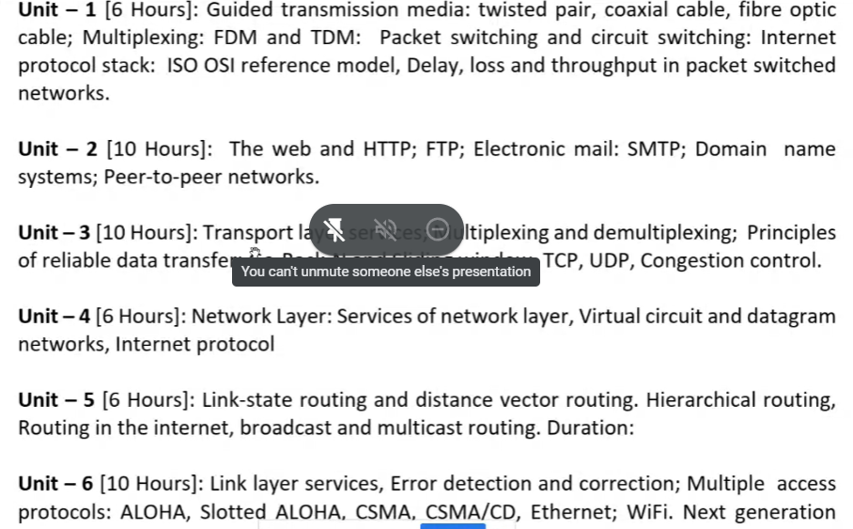

**Exams**

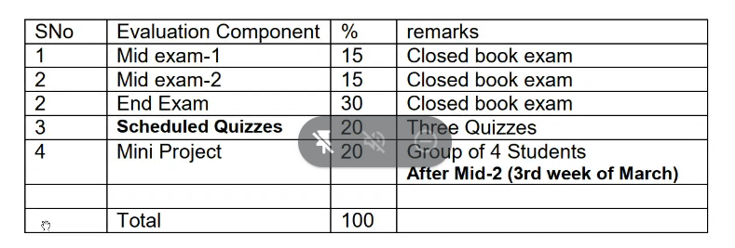

**Lec-1   
06.01.2020**

* Network is an interconnection of devices in which fragmented data is being transferred.
* 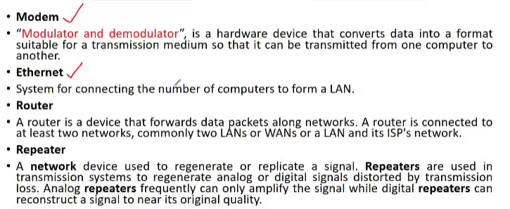

**Classification**

* + Unicasting(one to one)
  + Broadcasting(one to many)
  + Multicasting
  + PANs(personal
  + MANs(metropolitan)
  + WANs(wide) -> Internet
* Physical layer is in the lowest of protocol motel and it defines electrical, timing and other interfaces by which bits are sent as signals over channels.
* 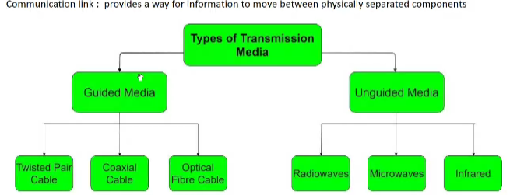
* Twisted pair:- example - cable phones
* Multiplexing:- a technique which combines multiple signal into one , it reduces cost.
* FDM:- used in TV,radio.  
   bandwidth of communication channel> total of individual signals  
   separation b/w two signals is guard band(narrow)  
   need a large bandwidth communication channel(disadvantage)
* WDM:- Simiilar to FDM but here we deal with FDM  
   used in multi core optical fiber
* TDM:- here we divide time to each user  
   Don’t need multiple frequency(Adv)  
   Types:-  
   Sync.(fixed time slots),(no. of transmission= no. of transmitters) and Async. Transmission(more complex)(flexible)
* Circuit Switching
* Packet Switching  
   data is transferred through packets, data is send to buffer bit by bit and packets are formed and then packets are shared to destination